Primary Sources and Transcriptions: Declaration Remix

# Description

This packet includes 3 scanned images of primary source documents for the “Declaration of Independence Remix” lesson plan.

# Table of Contents

1754 Slave Census

1785 William Bentley Diary

1776 Declaration of Independence

# Transcription Guidelines

When transcribing the handwritten documents, the overall goals for us were to (1) make the text more readable and understandable for the audience and (2) to do so while keeping as much of the original text as possible. Some documents contain text that is not relevant to the lesson.

# Donor Recognition and Thank You

This program was made possible by a grant from the National Park Foundation through the generous support of Union Pacific Railroad and donors across the country. Special thank you to The Phillips Library, Peabody Essex Museum, The Hard History Project, and the Lynn, Salem, and Saugus Public Schools.

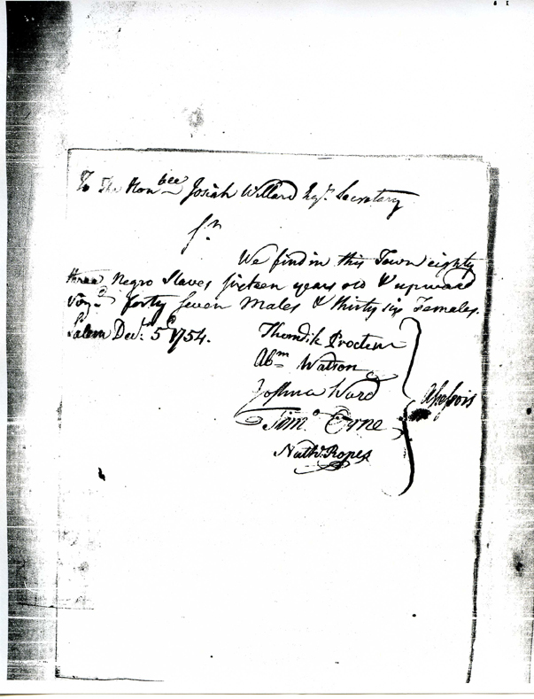

1754 Salem Slave Census

Transcription

We find in the Town eighty

three Negro Slaves fifteen years old + upward

[illegible] forty seven males & thirty six Females.

Salem Dec:r 5th 1754

Citation and Credit: Primaryresearch.org - 1754 Massachusetts Slave Census compiled from the Massachusetts State Archives

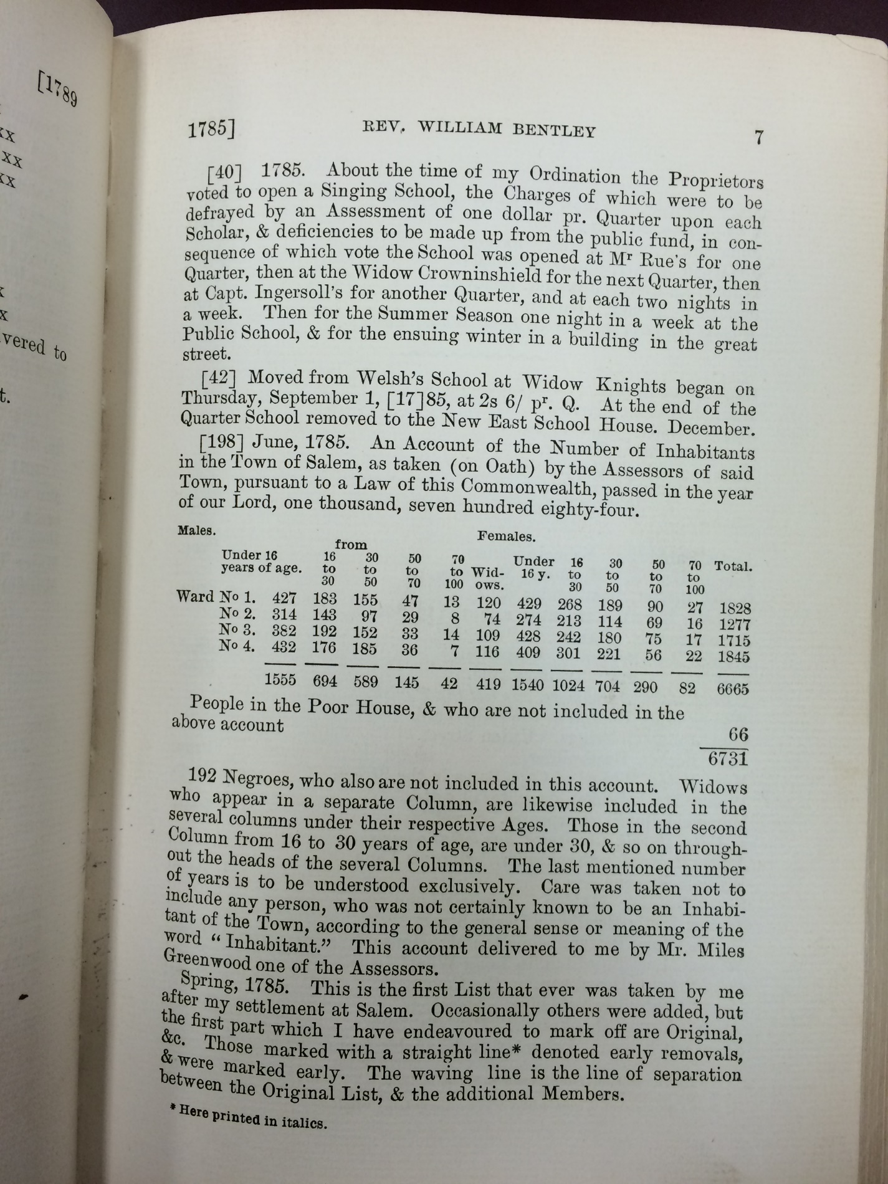

Citation and Credit: Bentley, W., Waters, A. G., Dalrymple, M., Waters, J. Gilbert., Essex Institute. (1905). *The diary of William Bentley, D. D..* Salem, Mass.: The Essex Institute, 7. (https://hdl.handle.net/2027/yale.39002005662607)

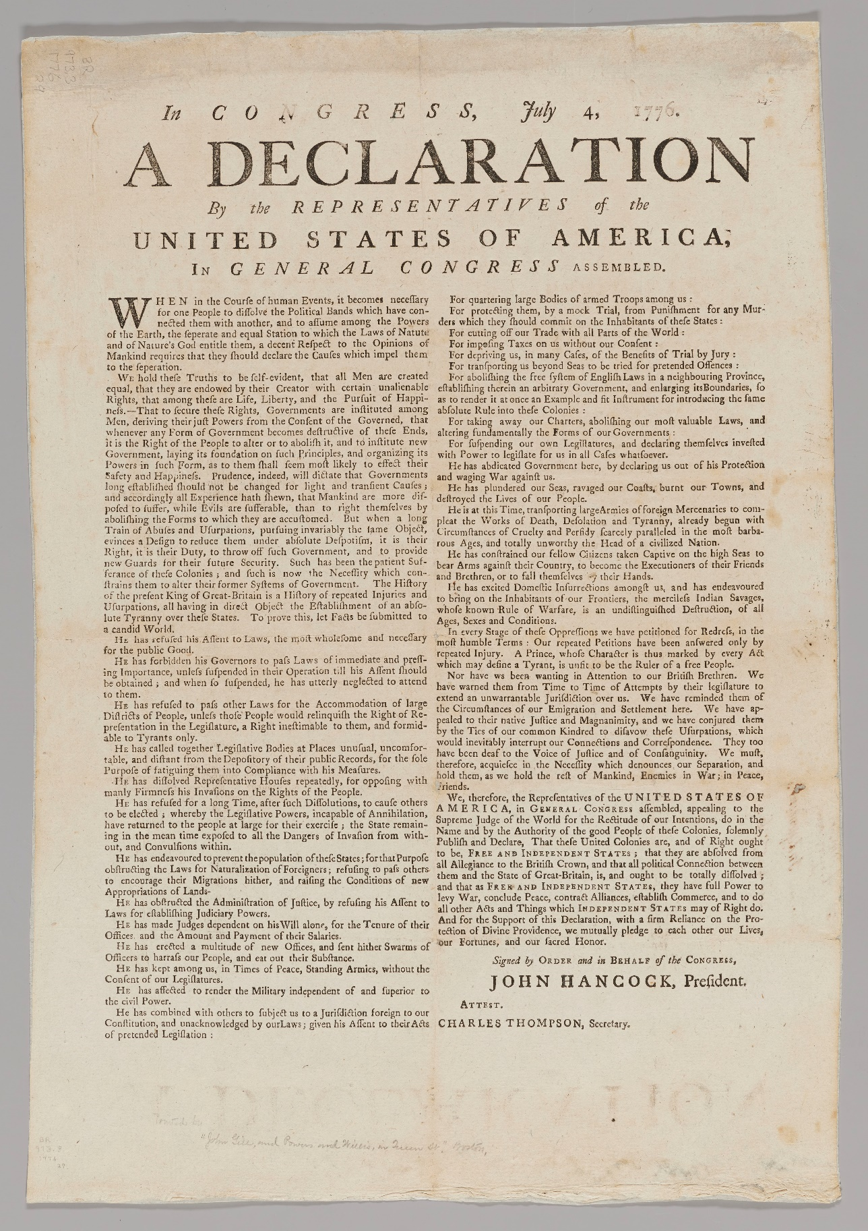Citation and Credit: Advertisement, 1774, Phillips Library Digital Collections (https://pem.quartexcollections.com)